Employee Management System

Project Documentation

1. Project Overview

1.1 Introduction
The Employee Management System (EMS) is a Java-based console application designed to manage employee information efficiently. The system allows users to store, retrieve, update, delete, and analyze employee records. It uses Java’s Collections Framework (ArrayList and HashMap) to store employee objects and provides fast access to employee data.
The application also supports file persistence using serialization, which ensures that employee data is saved to a file and can be loaded again when the program is restarted.
This project demonstrates key programming concepts such as:
- Object-Oriented Programming (OOP)
- Data structures and algorithms
- File handling
- Exception handling
- Modular program design

1.2 Project Goals and Objectives
The main objectives of the project are:
- To design a console-based employee management system.
- To store employee data efficiently using ArrayList.
- To enable fast search operations using HashMap.
- To implement CRUD operations (Create, Read, Update, Delete).
- To implement file handling using Java serialization.
- To generate reports such as salary statistics and department summaries.
- To demonstrate the use of Java collections, exception handling, and modular programming.

2. Setup Instructions

2.1 Software Requirements
To run the project, the following software is required:
- Java Development Kit (JDK) version 8 or higher

- Any Java IDE (optional)
  - IntelliJ IDEA
  - Eclipse
  - VS Code
- Command Line / Terminal

2.2 Project Files
The project consists of the following files:
Employee.java
EmployeeManagementSystem.java
EmployeeFileHandler.java
EmployeeReportGenerator.java
Each file has a specific role in the project.

2.3 Installation Steps
Follow these steps to run the project:

Step 1: Download the Project Files
Place all Java files in the same directory.

Step 2: Open Terminal / Command Prompt
Navigate to the project directory.

Step 3: Compile the Program
javac *.java

Step 4: Run the Program
java EmployeeManagementSystem

2.4 Running the Application
After running the program, the following menu appears:
=== EMPLOYEE MANAGEMENT SYSTEM ===
1. Add New Employee
2. View All Employees
3. Search Employee
4. Update Employee
5. Delete Employee
6. Generate Reports
7. Save to File
8. Load from File
9. Exit
The user can select options to manage employee data.

3. Code Structure
The project is organized into four main classes.

3.1 Employee.java
This class represents an Employee object.

Responsibilities
- Stores employee attributes
- Implements serialization
- Provides getter and setter methods

Attributes
Attribute | Type | Description
id | String | Unique employee ID
name | String | Employee name
department | String | Department name
position | String | Job position
salary | double | Employee salary
joinDate | Date | Employee joining date

3.2 EmployeeManagementSystem.java
This is the main class that controls the program.

Responsibilities
- Displays the main menu
- Performs CRUD operations
- Calls report generator
- Handles user input
- Manages employee data

Data Structures Used
ArrayList<Employee>
- Stores all employees
- Allows dynamic data storage
HashMap<String, Employee>
- Key = Employee ID
- Value = Employee object
- Enables fast employee search

3.3 EmployeeFileHandler.java
This class manages file storage and retrieval.

Responsibilities
- Saving employee data
- Loading employee data
- Handling serialization

Methods
saveEmployees()
- Writes employee list to file
loadEmployees()
- Reads employee list from file

3.4 EmployeeReportGenerator.java
This class generates reports and statistics.

Reports Available
- Salary statistics
- Department summary
- Employee count by position

4. Data Format Specification
Employee data is stored in a file named:
employees.dat
The file stores data using Java Object Serialization.

Data Structure Stored
ArrayList<Employee>

Fields Stored
Field | Type
Employee ID | String
Name | String
Department | String
Position | String
Salary | double
Join Date | Date
The file is binary formatted and cannot be directly read as text.

5. File Handling Procedures
The system uses Java serialization to save and load employee data.

5.1 Saving Data
When the user selects:
7. Save to File
The system performs the following:
- Retrieves all employee objects from ArrayList.
- Uses ObjectOutputStream.
- Serializes the objects.
- Writes them into employees.dat.

5.2 Loading Data
When the user selects:
8. Load from File
The system:
- Opens employees.dat.
- Uses ObjectInputStream.
- Reads serialized employee objects.
- Restores them into ArrayList.
- Rebuilds HashMap for quick lookup.

6. Employee Management Workflows
The following workflow describes how the system operates.

6.1 Adding Employee
User enters:
Employee ID
Name
Department
Position
Salary

The employee is stored in:
ArrayList
HashMap

6.2 Viewing Employees
The system displays all employees stored in the ArrayList.

6.3 Searching Employee
Users can search by:
- Employee ID
- Name
- Department
HashMap enables fast search by ID.

6.4 Updating Employee
User enters employee ID and modifies fields such as:
- Name
- Department
- Position
- Salary

6.5 Deleting Employee
Employee is removed from:
ArrayList
HashMap

6.6 Generating Reports
The system generates:

Salary Statistics
Displays:
- Total employees
- Average salary
- Highest salary
- Lowest salary

Department Summary
Displays:
- Number of employees per department
- Average salary per department

7. Visual Documentation
- Main menu interface :-
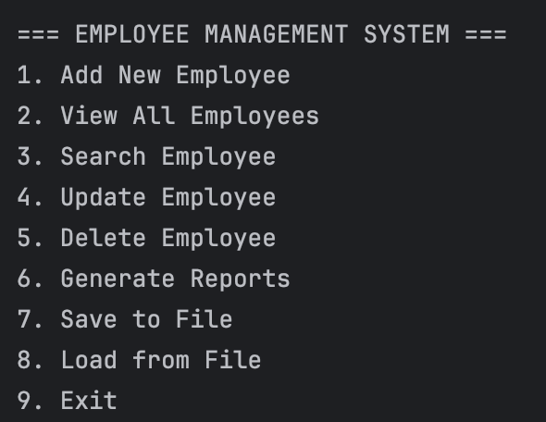

- Adding a new employee
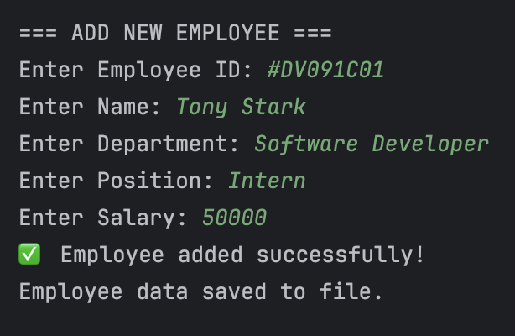

- Viewing all employees

- Searching employee by Employee ID:-

- Update Employee:-
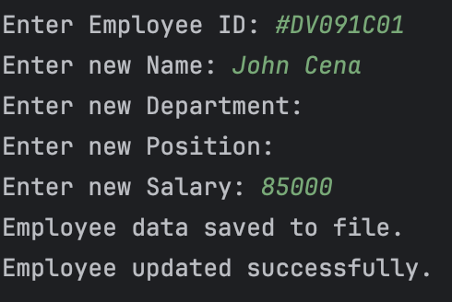

- Delete Employee:-
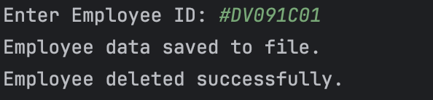
- Generate Reports:-
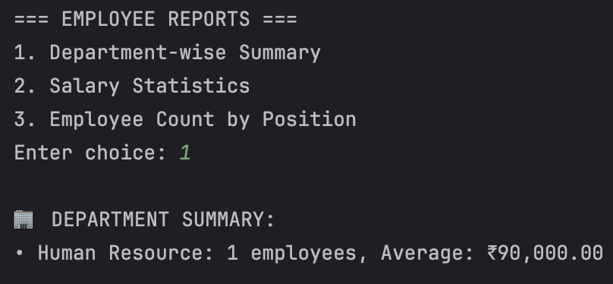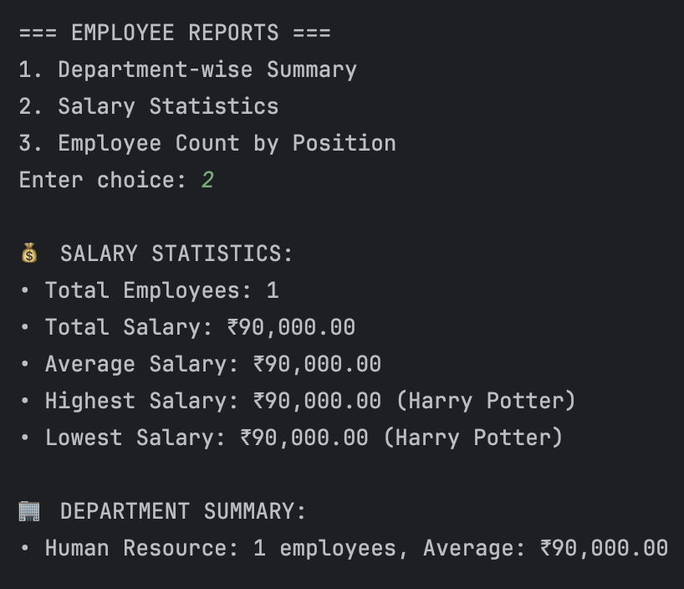
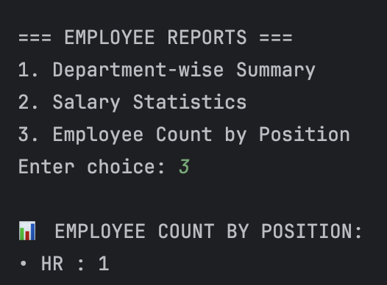

- Save to File :-


- Load from File :-
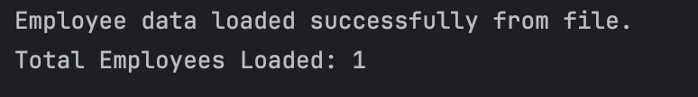
- Exit :-


8. Technical Details

Algorithms Used
The system mainly uses iteration algorithms for:
- Searching employees
- Calculating salary statistics
- Grouping employees by department

Data Structures Used
ArrayList
Used for storing employee objects dynamically.
Advantages:
- Dynamic resizing
- Easy traversal
- Efficient storage

HashMap
Used for fast employee lookup by ID.
Advantages:
- Constant time lookup O(1)
- Efficient data retrieval

System Architecture
The project follows modular architecture:
Employee (Data Model)
EmployeeManagementSystem (Controller)
EmployeeFileHandler (File Persistence)
EmployeeReportGenerator (Analytics)

9. Testing Evidence
Several test cases were performed to verify system functionality.

Test Case 1: Add Employee
Input:
ID: E001
Name: Alice Johnson
Department: Engineering
Position: Software Developer
Salary: 85000
Output:
Employee added successfully

Test Case 2: View Employees
Output:
ID: E001 Name: Alice Johnson Dept: Engineering

Test Case 3: Search Employee
Input:
Search by Department: Engineering
Output:
2 employees found

Test Case 4: Salary Report
Output:
Total Employees: 4
Average Salary: ₹90,000
Highest Salary: ₹105,000
Lowest Salary: ₹75,000

Test Case 5: File Save and Load
After saving:
employees.dat created
After loading:
Employee data loaded successfully

